实验报告
2019 年 6 月 13 日 成绩：
姓名 |  | 学号 |  | 班级
专业 | 计算机科学与技术 |  | 课程名称 | 计算机组成原理课程设计
任课老师 | 章复嘉 | 指导老师 | 章复嘉 | 机位号
实验序号 | 实验十 | 实验名称 | 实现R-I-J型指令的CPU设计实验
实验时间 | 2019．6.13 | 实验地点 | 1-225 | 实验设备号
一、实验目的和实验要求
掌握MIPS R型、I型和J型指令的综合数据通路设计
掌握各种转移类指令的控制流和指令流的多路选通控制方法；
二、实验程序源代码
`timescale 1ns / 1ps

module TOP_RIJ_CPU(
input [1:6]swb,
input clk, // 数码管相关
output [2:0] which,
output [7:0] seg,
output reg enable = 1, // 默认开启数码管使能
output reg [1:32]led
);
wire ZF;
wire OF;
wire [31:0]ALU_F;//运算结果数据
wire [31:0]M_R_Data;

Display Display_Instance(.clk(clk), .data(M_R_Data),
.which(which), .seg(seg));

//swb[1]clk,swb[2]rst
RIJ_CPU RIJ_CPU(swb[1],swb[2],ZF,OF,ALU_F,M_R_Data);

always@(*)
begin
if(swb[3])//按下swb[3]，led显示M_R_Data
led = ALU_F;
else if(swb[4])//按下swb[4],led显示ZF,OF
begin
led[1] = ZF;
led[2] = OF;
end
end
endmodule

`timescale 1ns / 1ps

module RIJ_CPU(
input clk,
input rst,
output ZF,
output OF,
output [31:0]ALU_F,
output [31:0]M_R_Data,
output [31:0]PC
);

wire [31:0]ALU_F;
wire [3:0]ALU_OP;
wire Write_Reg;
wire [1:0]wr_data_s;
wire [1:0]w_r_s;
wire imm_s,rt_imm_s,Mem_Write;//写入信号

wire [31:0]imm_data;//扩展后立即数
wire [4:0]W_Addr;

wire [1:0]PC_s;
wire [31:0]Inst_code;//取出的指令
wire [4:0]rs;
wire [4:0]rt;
wire [4:0]rd;
wire [15:0]imm;
wire [25:0]address;
wire [31:0]PC_new;
//reg [31:0]PC;//地址

wire [31:0]ALU_B;
wire [31:0]W_Data;
wire [31:0]R_Data_A;//A数据口
wire [31:0]R_Data_B;//B数据口

Gmips Gmips(clk,rst,PC_s,R_Data_A,imm_data,address,Inst_code,PC);

Control Control(Inst_code,ZF,Write_Reg,w_r_s,imm_s,rt_imm_s,wr_data_s,ALU_OP,Mem_Write,rs,rt,rd,imm,address,PC_s);

REG reg_test(clk,rst,Write_Reg,W_Data,rs,rt,W_Addr,R_Data_A,R_Data_B);

ALU alu_test(ALU_OP,R_Data_A,ALU_B,ZF,OF,ALU_F);

assign PC_new = PC+3'b100;
assign W_Addr = (w_r_s[1]) ? 5'b11111 : ((w_r_s[0]) ? rt : rd);
assign W_Data = (wr_data_s[1]) ? PC_new : ((wr_data_s[0]) ? M_R_Data : ALU_F);
assign imm_data=(imm_s) ? {{16{imm[15]}},imm} : {{16{1'b0}},imm};
assign ALU_B = (rt_imm_s) ? imm_data :R_Data_B;

reg clk_temp;

always@(*)
begin
if(clk) clk_temp<=1;
else clk_temp<=0;
end

Inst_RAM RAM (
.clka(clk_temp), // input wire clka
.wea(Mem_Write), // input wire [0 : 0] wea
.addra(ALU_F[5:0]), // input wire [5 : 0] addra
.dina(R_Data_B), // input wire [31 : 0] dina
.douta(M_R_Data) // output wire [31 : 0] douta
);

endmodule

`timescale 1ns / 1ps

module Gmips(clk,rst,PC_s,R_Data_A,imm_data,address,Inst_code,PC);
input clk;//时钟
input rst;//清零
input [1:0]PC_s;
input [31:0]R_Data_A;
input [31:0]imm_data;
input [25:0]address;
//input [31:0]PC_new;
output [31:0]Inst_code;//取出的指令
output reg [31:0]PC;//地址
wire [31:0]PC_new;

assign PC_new = PC+3'b100;//组合逻辑电路，不需要时钟控制

// always @(*)
// begin
// if(!clk&&rst) PC <=32'h00000000;//清零
// end

always @(negedge clk)
begin
if(rst) PC<=32'h00000000;//清零
//else PC <= PC_new;//下降沿的时候，把PC_new赋值给PC
else begin
case (PC_s)
2'b00: PC <= PC_new;
2'b01: PC <= R_Data_A;
2'b10: PC <= PC_new + (imm_data<<2);
2'b11: PC <= {PC_new[31:28], address, 2'b00};
endcase
end
end

//实例化模块
Inst_ROM Inst_Rom(
.clka(clk),
.addra(PC[7:2]),
.douta(Inst_code)
);

endmodule

`timescale 1ns / 1ps

module Control(Inst_code,ZF,Write_Reg,w_r_s,imm_s,rt_imm_s,wr_data_s,ALU_OP,Mem_Write,rs,rt,rd,imm,address,PC_s);
input [31:0]Inst_code;
input ZF;
output reg Write_Reg;
output reg [1:0]w_r_s;
output reg imm_s;
output reg rt_imm_s;
output reg [3:0]ALU_OP;
output reg Mem_Write;
output reg [4:0]rs;
output reg [4:0]rt;
output reg [4:0]rd;
output reg [15:0]imm;
output reg [25:0]address;
output reg [1:0]PC_s;
output reg [1:0]wr_data_s;

always@(*)
begin
if(Inst_code[31:26] == 6'b000000)
begin
rs = Inst_code[25:21];
rt = Inst_code[20:16];
rd = Inst_code[15:11];
Write_Reg = (Inst_code[5:0]==0)?1'b0:1'b1;
Mem_Write = 0;
w_r_s=2'b00;
rt_imm_s=0;
wr_data_s=2'b00;
PC_s=2'b00;
case(Inst_code[5:0])
6'b100100:begin ALU_OP = 4'b0000;end//逻辑与
6'b100101:begin ALU_OP = 4'b0001;end//逻辑或
6'b100110:begin ALU_OP = 4'b0010;end//逻辑异或
6'b100111:begin ALU_OP = 4'b0011;end//逻辑或非
6'b100000:begin ALU_OP = 4'b0100;end//算数加
6'b100010:begin ALU_OP = 4'b0101;end//算数减
6'b101011:begin ALU_OP = 4'b0110;end//若A<B，则F=1，否则输出0；
6'b000100:begin ALU_OP = 4'b0111;end//B逻辑左移A所指定的位数
6'b001000:begin Write_Reg = 1'b0;ALU_OP=4'b0100;PC_s=2'b01;end//jr rs
endcase
end
else if(Inst_code[31:27] == 5'b00001)
begin
address = Inst_code[25:0];
Mem_Write = 0;
PC_s=2'b11;
w_r_s=2'b10;
wr_data_s=2'b10;
case(Inst_code[31:26])
6'b000010:begin Write_Reg = 0;end//j label
6'b000011:begin Write_Reg = 1;end//jal label
endcase
end
else
begin
rs = Inst_code[25:21];
rt = Inst_code[20:16];
imm = Inst_code[15:0];
Write_Reg=1;
wr_data_s=2'b00;
w_r_s = 2'b01;
rt_imm_s = 1;
imm_s = 0;
PC_s = 2'b00;
case(Inst_code[31:26])
6'b001000:begin imm_s = 1;ALU_OP = 4'b0100;Mem_Write =0;end//addi rt rs imm
6'b001100:begin ALU_OP = 4'b0000;Mem_Write =0;end//andi rt rs imm
6'b001110:begin ALU_OP = 4'b0010;Mem_Write =0;end//xori rt rs imm
6'b001011:begin ALU_OP = 4'b0110;Mem_Write =0;end//slutiu rt rs imm
6'b100011:begin imm_s = 1;wr_data_s = 2'b01;ALU_OP = 4'b0100;Mem_Write =0;end//lw rt offset(rs)
6'b101011:begin imm_s = 1;ALU_OP = 4'b0100;Write_Reg = 0; Mem_Write = 1;end//sw rt offset(rs)
6'b000100:begin rt_imm_s = 0;ALU_OP=4'b0101;Write_Reg = 0; Mem_Write = 0;PC_s=(ZF?2'b10:2'b00);end//beq rs rt label
6'b000101:begin rt_imm_s = 0;ALU_OP=4'b0101;Write_Reg = 0; Mem_Write = 0;PC_s=(ZF?2'b00:2'b10);end//bne rs rt label
endcase
end
end
endmodule

`timescale 1ns / 1ps

module REG(clk,rst,Write_Reg,W_Data,R_Addr_A,R_Addr_B,W_Addr,R_Data_A,R_Data_B);
input clk,rst;//时钟，复位
input Write_Reg;//写入信号
input [4:0]R_Addr_A;//寄存器号
input [4:0]R_Addr_B; //寄存器号
input [4:0]W_Addr;//寄存器号
input [31:0]W_Data;//写入数据
output [31:0]R_Data_A;//A数据口
output [31:0]R_Data_B;//B数据口
integer i; //想到于int i,用于初始化数组
reg [31:0] REG_Files[0:31];

initial//初始化32个寄存器，全为0
for(i=0;i<31;i=i+1) REG_Files[i]<=0;

assign R_Data_A = REG_Files[R_Addr_A];
assign R_Data_B = REG_Files[R_Addr_B];

always @(negedge clk or posedge rst)
begin
if(rst) //高电平有效，=1则初始化
begin
for(i=0;i<32;i=i+1)begin
REG_Files[i] <= 0;
end
end
else
begin
if (Write_Reg && W_Addr>0)
REG_Files[W_Addr] <= W_Data;//写入寄存器;
end
end
endmodule

`timescale 1ns / 1ps

module ALU(ALU_OP,A,B,ZF,OF,F);
input [3:0]ALU_OP;//16选一
input [31:0]A;
input [31:0]B;
output ZF;//结果为零标志ZF
output OF;//溢出标志位OF
output [31:0]F;
reg [31:0]F;
reg ZF,OF,C;

always @(*)
begin
C=0; //进位借位标志
case(ALU_OP)
4'b0000:begin F=A&B;end //逻辑与
4'b0001:begin F=A|B;end //逻辑或
4'b0010:begin F=A^B;end //逻辑异或
4'b0011:begin F=~(A|B);end // 逻辑或非
4'b0100:begin {C,F}=A+B;end //算数加
4'b0101:begin {C,F}=A-B;end //算数减
4'b0110:begin F=A<B;end //若A<B,则F=1，否则输出0
4'b0111:begin F=B<<A;end //B逻辑左移A所指定的位数
endcase
//assign led = F;
ZF = F == 0;
OF = A[31]^B[31]^F[31]^C;
end

endmodule

ROM.coe
memory_initialization_radix=16;
memory_initialization_vector=00002020, 20050014, 2006000a, 0c000004, 00804020, 00a04820, 00c05020, 8d0b0000, ad2b0000, 21080004,21290004,214affff,1540fffa, 03e00008;

RAM.coe
memory_initialization_radix=16;
memory_initialization_vector=00000001,00000002,00000003,00000004,00000005,00000006,00000007,00000008,00000009,0000000a,0000000b,0000000c,0000000d,0000000e,0000000f,00000010,00000011,00000012,00000013,00000014,00000015,000000016,00000017,8888888,99999999,aaaaaaaa,bbbbbbbb,00000820,00632020,00010fff,20006789,FFFF0000,0000FFFF,0000FFFF,88888888,99999999,00010fff,20006789,FFFF0000,0000FFFF,8888888,99999999,aaaaaaaa,bbbbbbbb,00000820,00632020,00010fff,20006789,FFFF0000,0000FFFF;

三、仿真文件和波形图（有就填，没有就不填）
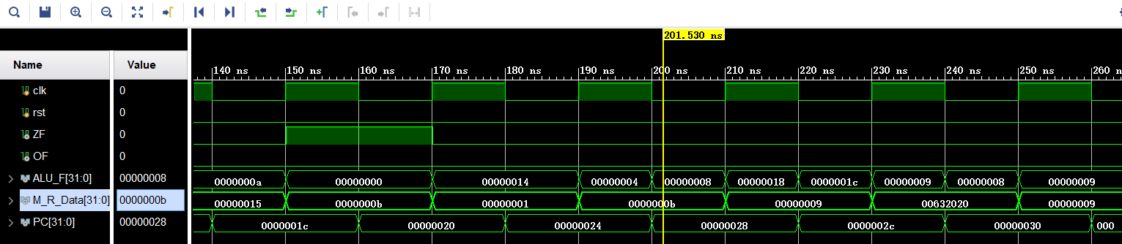
`timescale 1ns / 1ps

module Test_RIJ_CPU();
reg clk;
reg rst;
// reg clk_temp;
wire ZF;
wire OF;
wire [31:0]ALU_F;
wire [31:0] M_R_Data;
wire [31:0]PC;
RIJ_CPU rij_cpu(
.clk(clk),
.rst(rst),
// .clk_temp(clk_temp),
.ZF(ZF),
.OF(OF),
.ALU_F(ALU_F),
.M_R_Data(M_R_Data),
.PC(PC)
);

initial clk=0;
always #10 clk=~clk;
initial begin
rst = 1;
#10;
rst=0;
end

endmodule

四、电路图（有就填，没有就不填）
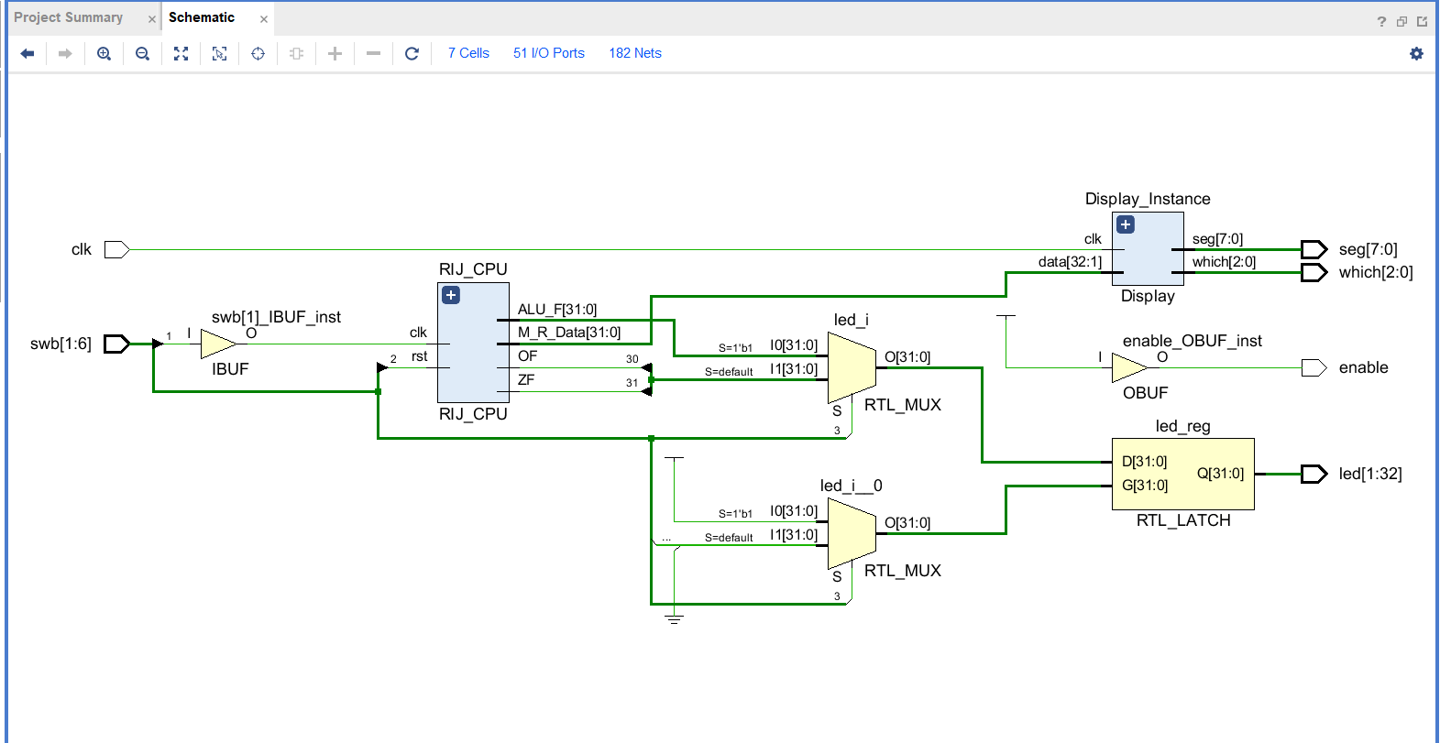
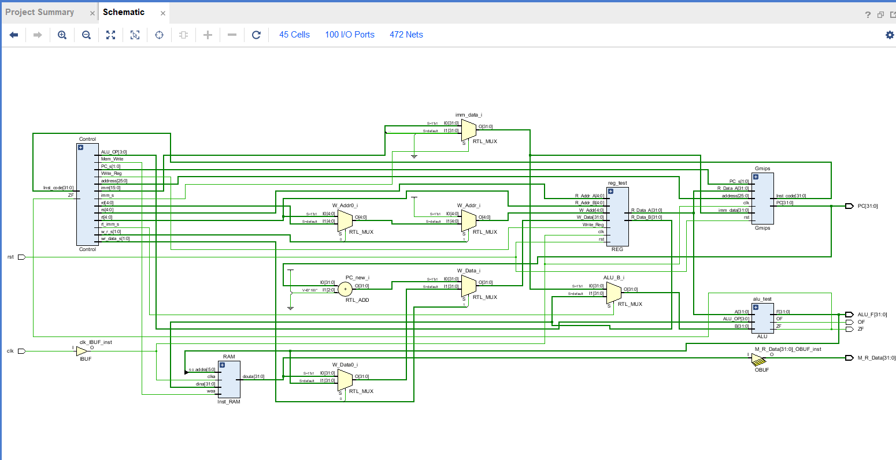
五、引脚配置（约束文件，有就填，没有就不填））
# 开启比特流压缩，优化 .bit 文件大小
set_property BITSTREAM.GENERAL.COMPRESS TRUE [current_design]

# Switch，开关
set_property PULLDOWN true [get_ports sw]
set_property IOSTANDARD LVCMOS18 [get_ports sw]
set_property PACKAGE_PIN T3 [get_ports {sw[32]}]
set_property PACKAGE_PIN U3 [get_ports {sw[31]}]
set_property PACKAGE_PIN T4 [get_ports {sw[30]}]
set_property PACKAGE_PIN V3 [get_ports {sw[29]}]
set_property PACKAGE_PIN V4 [get_ports {sw[28]}]
set_property PACKAGE_PIN W4 [get_ports {sw[27]}]
set_property PACKAGE_PIN Y4 [get_ports {sw[26]}]
set_property PACKAGE_PIN Y6 [get_ports {sw[25]}]
set_property PACKAGE_PIN W7 [get_ports {sw[24]}]
set_property PACKAGE_PIN Y8 [get_ports {sw[23]}]
set_property PACKAGE_PIN Y7 [get_ports {sw[22]}]
set_property PACKAGE_PIN T1 [get_ports {sw[21]}]
set_property PACKAGE_PIN U1 [get_ports {sw[20]}]
set_property PACKAGE_PIN U2 [get_ports {sw[19]}]
set_property PACKAGE_PIN W1 [get_ports {sw[18]}]
set_property PACKAGE_PIN W2 [get_ports {sw[17]}]
set_property PACKAGE_PIN Y1 [get_ports {sw[16]}]
set_property PACKAGE_PIN AA1 [get_ports {sw[15]}]
set_property PACKAGE_PIN V2 [get_ports {sw[14]}]
set_property PACKAGE_PIN Y2 [get_ports {sw[13]}]
set_property PACKAGE_PIN AB1 [get_ports {sw[12]}]
set_property PACKAGE_PIN AB2 [get_ports {sw[11]}]
set_property PACKAGE_PIN AB3 [get_ports {sw[10]}]
set_property PACKAGE_PIN AB5 [get_ports {sw[9]}]
set_property PACKAGE_PIN AA6 [get_ports {sw[8]}]
set_property PACKAGE_PIN R2 [get_ports {sw[7]}]
set_property PACKAGE_PIN R3 [get_ports {sw[6]}]
set_property PACKAGE_PIN T6 [get_ports {sw[5]}]
set_property PACKAGE_PIN R6 [get_ports {sw[4]}]
set_property PACKAGE_PIN U7 [get_ports {sw[3]}]
set_property PACKAGE_PIN AB7 [get_ports {sw[2]}]
set_property PACKAGE_PIN AB8 [get_ports {sw[1]}]

# Switch Button，按钮
set_property IOSTANDARD LVCMOS18 [get_ports swb]
set_property PACKAGE_PIN R4 [get_ports {swb[1]}]
set_property PACKAGE_PIN AA4 [get_ports {swb[2]}]
set_property PACKAGE_PIN AB6 [get_ports {swb[3]}]
set_property PACKAGE_PIN T5 [get_ports {swb[4]}]
set_property PACKAGE_PIN V8 [get_ports {swb[5]}]
set_property PACKAGE_PIN AA8 [get_ports {swb[6]}]

# LED
set_property IOSTANDARD LVCMOS18 [get_ports led]
set_property PACKAGE_PIN R1 [get_ports {led[1]}]
set_property PACKAGE_PIN P2 [get_ports {led[2]}]
set_property PACKAGE_PIN P1 [get_ports {led[3]}]
set_property PACKAGE_PIN N2 [get_ports {led[4]}]
set_property PACKAGE_PIN M1 [get_ports {led[5]}]
set_property PACKAGE_PIN M2 [get_ports {led[6]}]
set_property PACKAGE_PIN L1 [get_ports {led[7]}]
set_property PACKAGE_PIN J2 [get_ports {led[8]}]
set_property PACKAGE_PIN G1 [get_ports {led[9]}]
set_property PACKAGE_PIN E1 [get_ports {led[10]}]
set_property PACKAGE_PIN D2 [get_ports {led[11]}]
set_property PACKAGE_PIN A1 [get_ports {led[12]}]
set_property PACKAGE_PIN L3 [get_ports {led[13]}]
set_property PACKAGE_PIN G3 [get_ports {led[14]}]
set_property PACKAGE_PIN K4 [get_ports {led[15]}]
set_property PACKAGE_PIN G4 [get_ports {led[16]}]
set_property PACKAGE_PIN K1 [get_ports {led[17]}]
set_property PACKAGE_PIN J1 [get_ports {led[18]}]
set_property PACKAGE_PIN H2 [get_ports {led[19]}]
set_property PACKAGE_PIN G2 [get_ports {led[20]}]
set_property PACKAGE_PIN F1 [get_ports {led[21]}]
set_property PACKAGE_PIN E2 [get_ports {led[22]}]
set_property PACKAGE_PIN D1 [get_ports {led[23]}]
set_property PACKAGE_PIN B1 [get_ports {led[24]}]
set_property PACKAGE_PIN B2 [get_ports {led[25]}]
set_property PACKAGE_PIN N3 [get_ports {led[26]}]
set_property PACKAGE_PIN M3 [get_ports {led[27]}]
set_property PACKAGE_PIN K3 [get_ports {led[28]}]
set_property PACKAGE_PIN H3 [get_ports {led[29]}]
set_property PACKAGE_PIN N4 [get_ports {led[30]}]
set_property PACKAGE_PIN L4 [get_ports {led[31]}]
set_property PACKAGE_PIN J4 [get_ports {led[32]}]

# 数码管相关
set_property IOSTANDARD LVCMOS18 [get_ports seg]
set_property PACKAGE_PIN H19 [get_ports {seg[7]}]
set_property PACKAGE_PIN G20 [get_ports {seg[6]}]
set_property PACKAGE_PIN J22 [get_ports {seg[5]}]
set_property PACKAGE_PIN K22 [get_ports {seg[4]}]
set_property PACKAGE_PIN K21 [get_ports {seg[3]}]
set_property PACKAGE_PIN H20 [get_ports {seg[2]}]
set_property PACKAGE_PIN H22 [get_ports {seg[1]}]
set_property PACKAGE_PIN J21 [get_ports {seg[0]}]
set_property IOSTANDARD LVCMOS18 [get_ports which]
set_property PACKAGE_PIN N22 [get_ports {which[0]}]
set_property PACKAGE_PIN M21 [get_ports {which[1]}]
set_property PACKAGE_PIN M22 [get_ports {which[2]}]
set_property -dict {IOSTANDARD LVCMOS18 PACKAGE_PIN L21} [get_ports enable]
set_property -dict {IOSTANDARD LVCMOS18 PACKAGE_PIN H4} [get_ports clk]

# [Place 30-574] Poor placement for routing between an IO pin and BUFG.If this
# sub optimal condition is acceptable for this design, you may use the
# CLOCK_DEDICATED_ROUTE constraint in the .xdc file to demote this message to a
# WARNING. However, the use of this override is highly discouraged.
set_property CLOCK_DEDICATED_ROUTE FALSE [get_nets clk_IBUF]
set_property CLOCK_DEDICATED_ROUTE FALSE [get_nets swb_IBUF[1]]
set_property CLOCK_DEDICATED_ROUTE FALSE [get_nets swb_IBUF[2]]
set_property CLOCK_DEDICATED_ROUTE FALSE [get_nets swb_IBUF[3]]
set_property CLOCK_DEDICATED_ROUTE FALSE [get_nets swb_IBUF[4]]
set_property CLOCK_DEDICATED_ROUTE FALSE [get_nets swb_IBUF[5]]
set_property CLOCK_DEDICATED_ROUTE FALSE [get_nets swb_IBUF[6]]
七、实验收获（心得体会等，请以个人为单位分别写）
- 在实验九的基础上加入几个指令，难度不大
- 实验书和PPT上的机器码存在错误，验证程序需要确定机器码是否正确。

